**Login/Register Page Design**

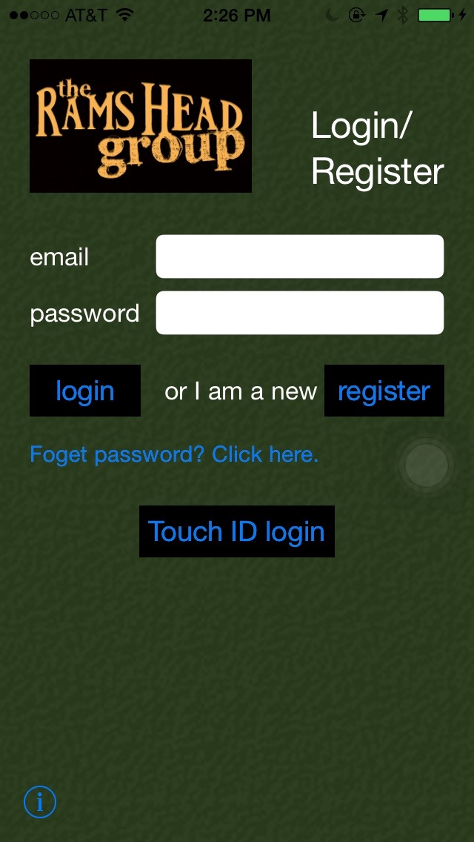**Elements:**

Background: dark green(the same as the website)

Company logo: on the up-left corner, 150x90

Page title: “Login/Register”, white, size 27

“email” label, “password” label, ”or I am a new user,” label: white, size 17

“email” input text field: size 14, email keyboard, Q4

“password” input text field: secure text entry

“login” button:

black background, blue font, segue to list page

“register” button:

black background, blue font, send request to register an account and login

“Foget password? Click here.” button:

segue to Reset password page.

“Touch ID login” button:

Use new feature “Touch ID” authorization in iOS8 to login

“i” (info) button: go back and view the introduction.

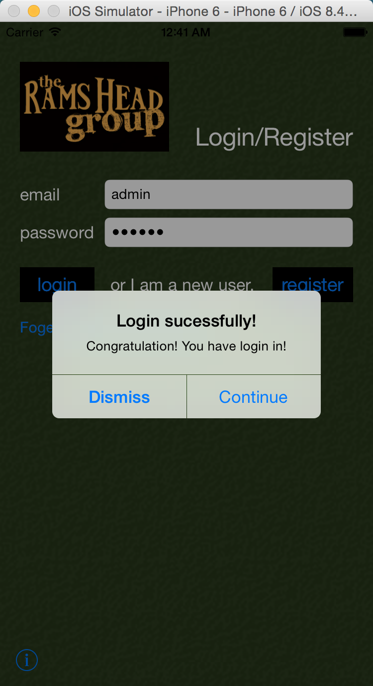

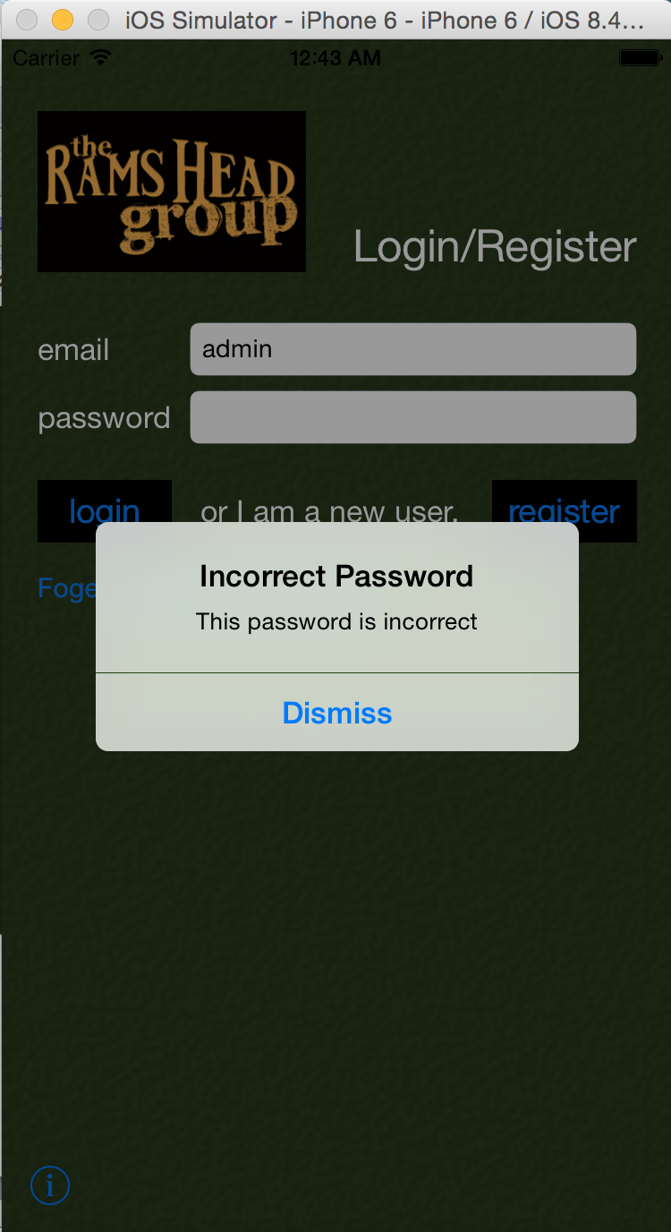

Login with touch ID:(Test in real device)

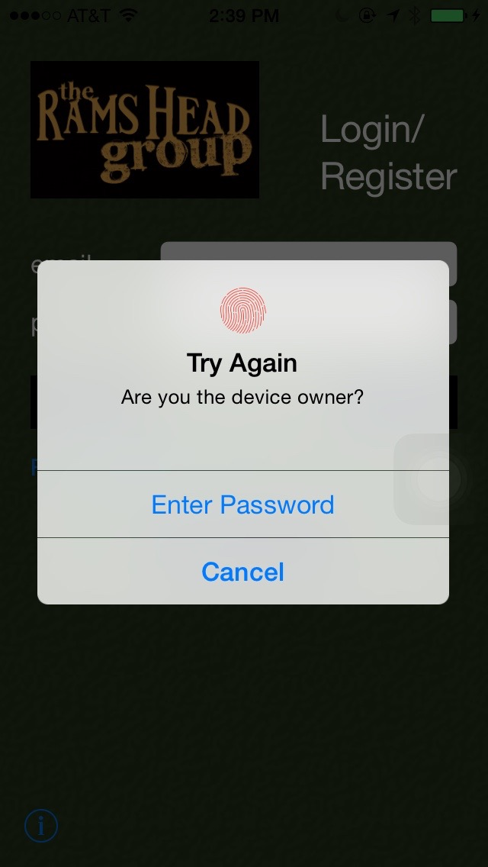

Fail:

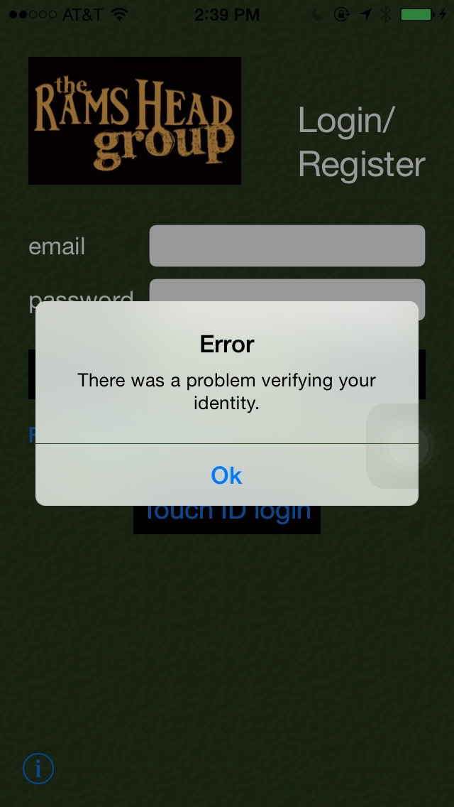

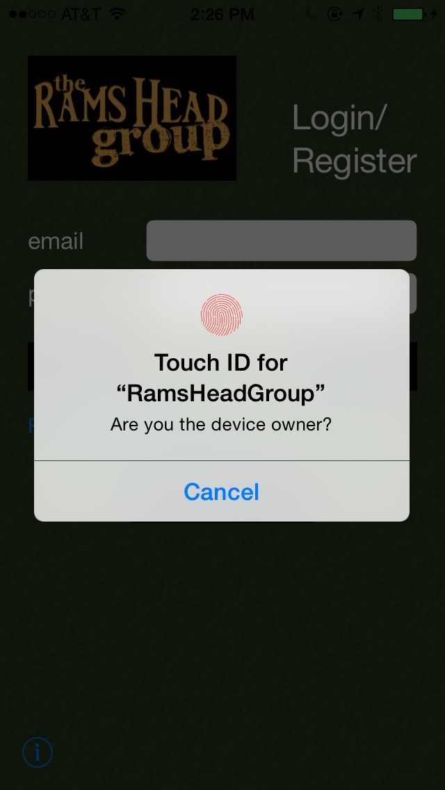

Success: